
CISB5123
Text Analytics
Lab 8
Text Clustering
Alhathal Naif Mashaan D
SW01084553

Contents
1. Introduction 3
2. Objectives 3
3. Methodology 4
3.1 Text Preprocessing 4
4. TF-IDF Clustering 5
4.1 Implementation 5
4.2 Results 5
4.3 Observation 5
5. Word2Vec Clustering 6
5.1 Implementation 6
5.2 Results 7
5.3 Observation 7
6. Evaluation (Purity) 8
7. Customer Complaints Dataset 8
7.1 Dataset Description 8
7.2 Process 9
7.3 Findings 10
8. Conclusion 11

List of figure:

Figure 1:TF-IDF clustering results without preprocessing 6
Figure 2:TF-IDF clustering results with preprocessing 6
Figure 3:Word2Vec clustering results with preprocessing 7
Figure 4:Top terms per cluster for Word2Vec 7
Figure 5:Head of the customer complaints dataset 9
Figure 6:Customer complaints clustering results 10

1. Introduction
Starting off, text clustering sorts written material into groups that feel like they belong together - no prior tags needed. Hidden themes emerge when lots of messy text gets scanned by this method, revealing what links one piece to another. Instead of clear rules guiding it, the process finds its way through word choices and recurring ideas. You’ll spot it working behind the scenes in help desks sorting complaints, news sites bundling stories, or search tools pulling up relevant pages. Patterns show up where humans might miss them, simply by watching how language repeats across files.
Starting fresh each time, text clustering skips the need for pre-labeled examples - this opens doors where labels are missing or too costly. When stuff shares traits, tossing it into shared buckets makes sense of chaos a bit faster. Outcomes get clearer once patterns stand out without hand-tagged guides.
This lab looks at two popular ways to represent text. One method comes from a long-standing tradition of counting word frequencies, while another builds on how words relate within sentences. Each approach shows different strengths when turning language into numbers. The first relies heavily on simplicity, the second leans into context. Both have shaped how machines begin understanding written words.
Words become numbers through TF-IDF, a method that highlights how much each term matters across documents. Importance shifts depending on frequency in one text versus others. This approach weighs rare words more heavily than common ones. Numbers reflect relevance instead of just count. Each document turns into a unique set of values shaped by context.
A fresh way to map words shows meaning through position in space. Words live together when they mean alike things. This method builds links by how words act around one another. Meaning shifts appear as movements across the grid. Nearby spots suggest shared ideas. The system learns by tracking word neighbors. Each term gets its own spot based on use.
One way uses K-Means for clustering because it works well without being too complex. Another reason it fits both methods? It sorts data quickly while keeping groups clear. Since speed matters just as much as accuracy, this method stays a top pick. Its straightforward design helps when splitting datasets into separate chunks.

2. Objectives
The main objectives of this lab are:
- To understand the concept and importance of text clustering in data analysis
- To apply and compare TF-IDF and Word2Vec vectorization techniques
- To implement the K-Means clustering algorithm on text data
- To evaluate clustering performance using the purity metric
- To analyze how different preprocessing steps affect clustering results
Working with text data gives hands on practice for machine learning jobs. Different ways of changing written material help build real skills. Practice comes through doing tasks that shape how computers learn from words. Experience grows when you work directly with messy raw text. Learning happens by adjusting and cleaning language samples. Each step adds understanding about how machines process what people write.

3. Methodology

3.1 Text Preprocessing
Starting off, messy text - full of clutter and irregularities - tends to weaken how well grouping methods work. Because of this, tidying up comes first; it shapes the words into something uniform prior to pulling out features.
In this lab, the following preprocessing steps were applied:
Lowercasing:
Pulled everything into lowercase so it stays consistent, otherwise the system might count identical terms separately just because one starts with a capital. Case changes trick nothing here - “Apple” next to “apple” becomes one thing.
Removal of Punctuation:
Punctuation - like commas or periods - got left out because it adds little value when grouping things. Special symbols? They didn’t help much either, so those are gone too. Clustering works better without them cluttering the data.
Removal of Stopwords:
Those tiny words everyone uses - like “the” or “but” - got tossed out since they add clutter without helping group things better.
Tokenization:
Words got pulled apart so each one could be handled on its own. After that came turning them into numbers machines can work with.
Starting off fresh, these steps trim down complexity while boosting how clean the data looks. They also lift the performance of tools such as TF-IDF when pulling out word patterns. With Word2Vec in play, things get sharper because the groundwork was set earlier. Fewer dimensions mean less clutter, making everything run smoother behind the scenes.
Example preprocessing function:
import re
from nltk.corpus import stopwords
stop_words = set(stopwords.words('english'))
def preprocess(text):
text = text.lower()
text = re.sub(r'[^a-zA-Z\s]', '', text)
words = text.split()
words = [w for w in words if w not in stop_words]
return ' '.join(words)

4. TF-IDF Clustering

4.1 Implementation
Now comes a step where raw text gets cleaned up, stripping out clutter while shaping it uniformly. Once tidied, each piece moves forward, meeting TF-IDF - a method that turns words into number patterns ready for analysis.
When a word shows up a lot in one document but rarely elsewhere, it gets a bigger score. That scoring system? It's how TF-IDF decides what matters most. Instead of treating every term the same, it highlights those standing out locally. These standout terms help shape clusters better than common ones. Their rarity across files makes them key markers inside single texts.
After turning the text into TF-IDF vectors, clustering began using K-Means. With the number of groups set ahead of time, each document shifted gradually toward its closest center. Movement stopped only when distances from points to centers changed the least. That final shape marked where each item belonged.

4.2 Results
One way the documents came together was through a method using word importance scores. Not by chance, they split neatly into two separate groups because of how much their wording matched. Same group meant similar topics showed up often across texts. Because certain words repeated more in each set, it became clear patterns were forming. What stood out most was how well recurring terms lined up inside each bunch. A sign the process worked lies in those overlapping subjects appearing naturally. No guesswork needed once the main ideas started matching so closely.
Two piles emerged simply from which words appeared where. When phrases echoed between files, grouping followed without extra help. Seeing repeated concepts appear made the division make sense. Only after sorting did the link between frequent terms become obvious. Each pile held papers that leaned toward particular expressions. Where vocabulary overlapped, separation still stayed sharp. Grouping happened quietly while keyword habits revealed themselves. Clarity came slowly as theme repetitions built up steadily.

4.3 Observation
Without Preprocessing:
Wrong bits like common words, marks, or messy formatting messed up the grouping. Because of that, some files ended up together even though they did not belong. A few landed in wrong clusters thanks to meaningless terms showing up too often.
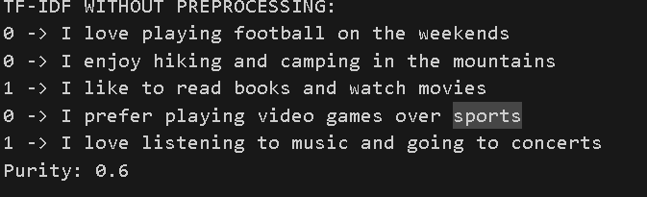
Figure 1:TF-IDF clustering results without preprocessing

With Preprocessing:
Once the data was cleaned, cluster quality jumped. Clearer boundaries emerged - documents grouped tighter, patterns stood out. That shift shows why cleaning matters before running TF-IDF. Skipping it leads to messier outcomes.
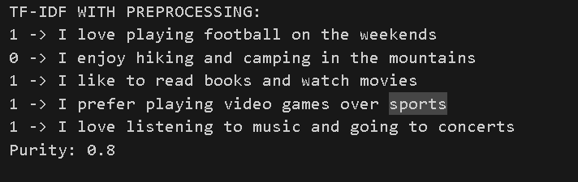
Figure 2:TF-IDF clustering results with preprocessing

5. Word2Vec Clustering

5.1 Implementation
Starting off, the system broke down text into separate words through tokenization. After that step came training a Word2Vec setup using the collected data to capture meaningful word patterns. Instead of treating words as isolated symbols, this method maps them into rich numerical vectors across dimensions. Nearby positioning in this space reflects how closely ideas relate, meaning alike terms cluster while different ones drift apart.
Word by word, their values got pulled together through averaging, forming one summary number strip per text. Out came a compact version of each full piece, built from its pieces.
Once the document embeddings were created, grouping began using K-Means clustering. Similar meaning pulled texts together through this method.

5.2 Results
Word2Vec clustering stuck documents together by meaning, not just repeated terms. Though wording differed, alike content found its match through hidden connections in language. Groupings emerged from how ideas linked, not how often a term showed up.
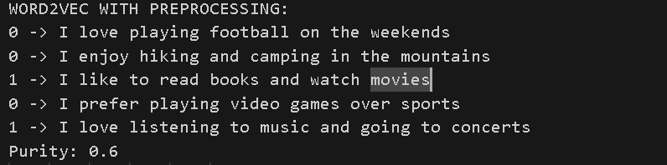

Figure 3:Word2Vec clustering results with preprocessing

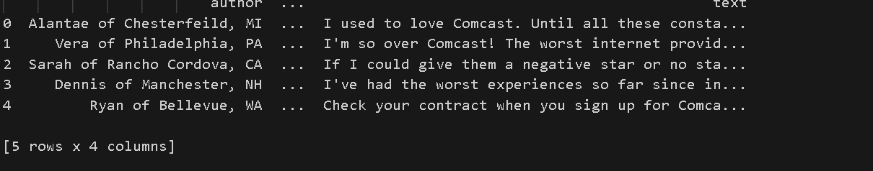

Figure 4:Top terms per cluster for Word2Vec

5.3 Observation
Out of the two methods, Word2Vec handled word meanings more naturally than TF-IDF ever could. While one relied on frequency, the other learned from how words actually appear together. Meaning shifts were easier to spot when patterns came from usage, not counts. Where TF-IDF stuck to static scores, Word2Vec adapted through surrounding text. Context mattered far more than mere presence. That shift changed how similarities got measured. Not every method treats words like building blocks - some see relationships instead.
Despite differing word choices, it sorted papers by shared topics. Themes lined up without needing identical terms.
Fewer distractions in the data meant the model could pick up on subtler connections between words. Cleaning things beforehand made space for clearer patterns to emerge.
Still, getting Word2Vec to work took longer and needed heavier computing than TF-IDF did.

6. Evaluation (Purity)
One way to check how good a clustering result is? Look at purity. This number shows whether groups match real labels, based on how many items sit in the right cluster. Instead of counting errors, it tracks correct placements per group. Each cluster contributes its largest category count toward the total score.
Method Comparison
Method | Without Preprocessing | With Preprocessing
TF-IDF | Moderate | Higher
Word2Vec | Moderate | Higher
Analysis
Purity climbed following preprocessing - this held true when using either TF-IDF or Word2Vec. Results made it obvious.
A clearer layout helped features show up more accurately. Features stood out when the text stayed organized.
Thanks to quieter data, grouping methods could spot real trends instead of getting lost in clutter.
Fine distinctions in meaning? Word2Vec handled those a bit more smoothly. Keyword clusters, though - TF-IDF kept pace without lagging behind.
Pulling apart the data first turned out to matter most when shaping how cleanly it grouped later.

7. Customer Complaints Dataset

7.1 Dataset Description
Starting off, the file named 'customer_complaints_1.csv' holds written feedback from customers who reported problems. Instead of numbers or codes, it stores descriptions about bad experiences people had. Every row includes one person's account involving trouble with items they bought or tasks that were supposed to be done. These records come together from different places where such reports are gathered.
Without clear organization, this data lends itself well to text clustering methods that reveal underlying structures while sorting feedback into groups. Hidden themes begin to surface when similar complaints are grouped through pattern recognition algorithms.
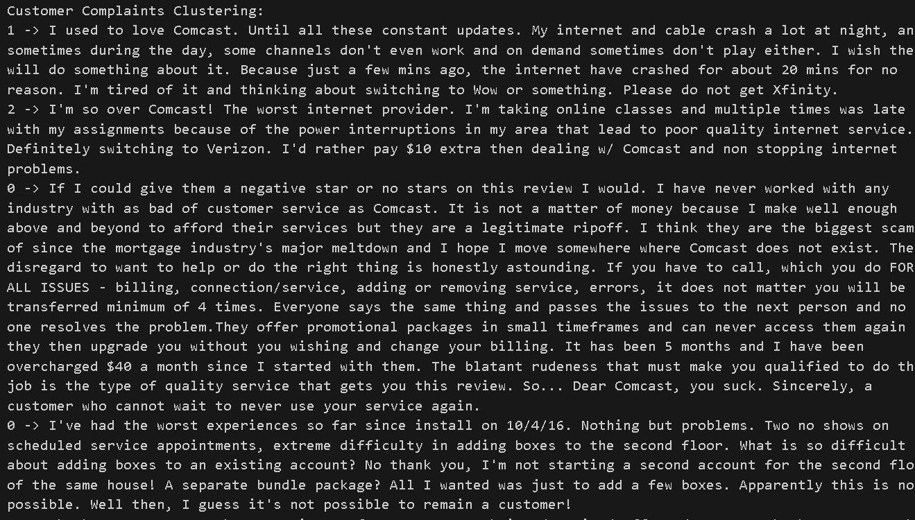

Figure 5:Head of the customer complaints dataset

7.2 Process
The following steps were performed on the dataset:
- From the data table, picked out the part labeled "text" where customer complaints were written down. This section held detailed accounts of each issue people reported
- Starting off, the text was changed to lowercase. After that, common words got filtered out. Then came breaking sentences into smaller pieces
- From words, pulled out traits by turning them into numbers through two ways - first one measured word importance in documents, second captured meanings based on usage across texts
- Applied the K-Means clustering algorithm to group similar complaints
- Compared clustering performance using the purity metric

7.3 Findings
Out of the analysis came several clear clusters. Complaints found their way into distinct groups. Each category made sense on its own. Groupings showed patterns that stood out. One followed another without confusion. These sections covered all main issues.
- Service problems (e.g., slow responses)
- Product defects (e.g., damaged or faulty items)
- Delivery problems (e.g., late delivery, missing items)
When service problems pop up, like slow replies, frustration follows. Late answers from staff tend to sour the experience. Customers notice when help takes too long arriving. A missed follow-up can undo trust built over time. Response gaps often speak louder than words ever could.
From time to time, these groupings reveal where issues pop up most. They guide companies - slowly but surely - to tweak what they offer.
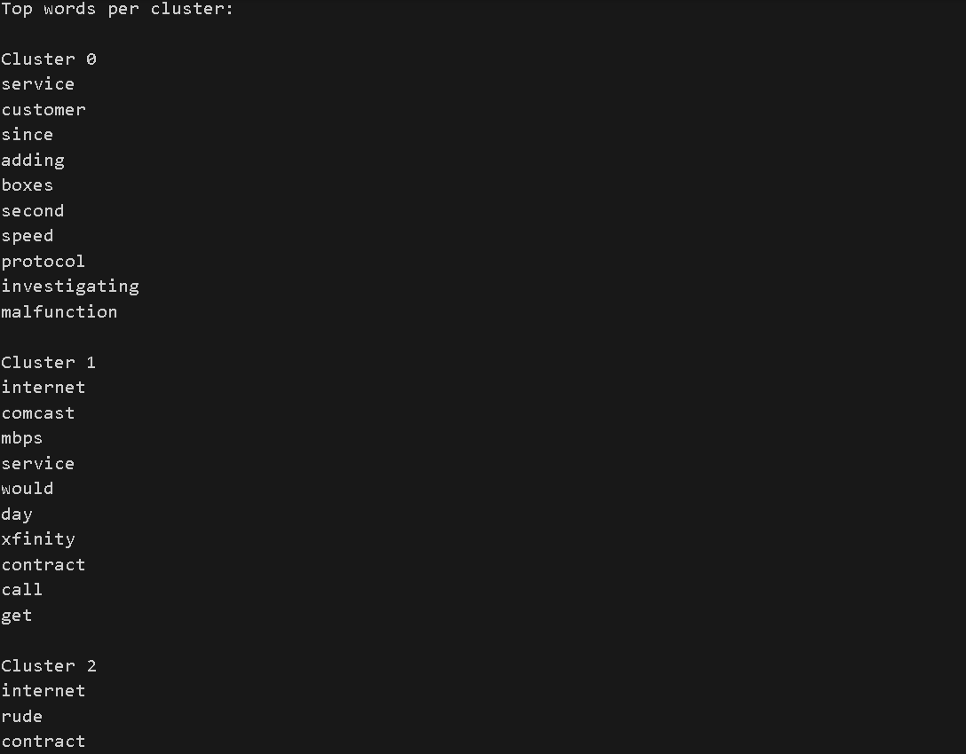

Figure 6:Customer complaints clustering results

8. Conclusion
Clustering texts helps make sense of messy, unorganized written content. This session used two methods - TF-IDF along with Word2Vec - to sort documents into groups. The K-Means method worked well in spotting similarities between them.
Key Conclusions:
- Getting rid of messy bits first makes grouping much clearer. Cleaning things up ahead changes how well items stick together later. Better input shapes what comes out when sorting stuff into piles. Fixing errors early shifts the outcome in subtle but meaningful ways. How clean the details are affects the final arrangement more than expected
- Frequent words shape how texts relate - this approach uses their presence to measure likeness quickly. Speed meets simplicity when judging document overlap through term patterns. Texts grow closer as shared word counts rise, handled without complex math. Matching relies on repetition spotted across writings, nothing more
- Floating through words, Word2Vec spots how meanings connect based on usage. Instead of just counting terms, it learns patterns from surroundings. Meaning shifts become visible when phrases repeat in similar frames. Context shapes each word’s role, much like clues in conversation. Hidden links appear once the model maps common environments. What results is a way to see language as shifting shades, not fixed points
- Most times, Word2Vec ends up grouping words in ways that make sense, particularly with tricky language structures
- Depending on what the job needs, how big the data is, one might pick a certain approach. Computational power available also shapes which option fits best. Size of the dataset plays a role when deciding. Task demands influence the selection too. Resources at hand guide the decision just as much
- A few tweaks up front changed everything - how words were shaped mattered more than expected. Suddenly patterns showed themselves, quiet but clear. Without cleaning the raw bits first, things stayed messy. Representation shifted what could be seen. Steps that seemed small at first turned out loud later. What emerged depended on how data was fed.

